Atiitt 。项目管理attilax心得

酒药素pmbpk十要素，attilax三五要素项目管理

[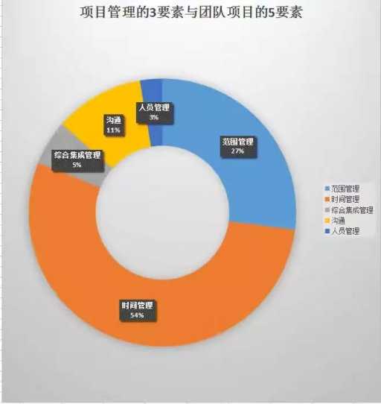](http://b264.photo.store.qq.com/psb?/V102lGb32Xf1vd/grtfPPzc0VMKaHGWdnqoL7hvO6emr04mkzQ2cBZtMSE!/c/dAgBAAAAAAAA&bo=kgK4AgAAAAAAAAw!)